Dear Colleagues,
These are the deadlines, information, and announcements for the week of 1st -5th April 2024

DEADLINES / IMPORTANT DATES:

Friday 3rd May 2024
Parent & Toddler Group Grant Application closing date

Friday 26th June 2024
Deadline for submission of Core Funding Financial reporting

FOR YOUR INFORMATION:
Core Funding Reporting Requirement Year 1

As you are aware Partner Services who signed up for Core Funding Year 1 (Sept 22- Aug 23) must now complete a financial report in respect of that year. This financial report consists of an Income & Expenditure report (template is available on Hive> Resources> Programme Documents> Core Funding documents> Core Funding financial reporting requirement year 1)

The Income & Expenditure report will be submitted on a new portal, which will open in two stages:
- The portal will be open to providers to register and to link with their nominated accountant on or before the 29th of April.
- The portal will be open on or before the 31st of May to accept completed Income and Expenditure report templates.
- The deadline for submission of the completed Income & Expenditure report template is 26th June.

Information Sessions

Cork County Childcare Committee are holding Information Sessions for ELC/SAC partner services on the Core Funding Financial Reporting requirements. These sessions will take place as follows:
Session 1: Tuesday 9th April 2.30pm (Online via Microsoft Teams)
Session 2: Thursday 11th April 6pm (Online via Microsoft Teams)
These short information sessions will outline the transitional requirements in place for year 1 and year 2 of Core Funding.

Click here to book:
https://forms.office.com/e/evGzgEANYm?origin=lprLink

If you require more detailed support, please contact your Development Worker.

Parent & Toddler Group Grants
The DCEDIY has announced the launch of the 2024 Parent and Toddler (P&T) Grant. This year the DCEDIY will continue to support P&T groups with a special focus on increased participation in P&T sessions of recently arrived parents and children from Ukraine and other countries.
Funding allocations for 2024 will be based on applications received and recommendations put forward by each CCC, subject to DCEDIY approval. The closing date for receipt of applications from Parent & Toddler groups is Friday 3rd May 2024. For a Grant Application Form please contact us on 022-23880 or info@corkchildcare.ie. The Press Release on the 2024 Parent and Toddler Grants can be viewed HERE.

AIM Information Sessions for Parents & Providers
Cork City and County Childcare Committees together with Better Start are hosting AIM information sessions for Providers & Parents. Both sessions will be held online on 1st May
Providers session @4pm-5pm
Parents session @7pm- 8pm
Please see booking details attached.

Consultation on the draft childminding regulations
Cork City & County Childcare Committees have scheduled another online Childminder Focus Group on the proposed new childminding regulations. This focus group will take place online on Monday 15th April from 7pm to 9pm.

If you are interested in attending this online session, please click on the link below to book your place https://forms.office.com/e/6FEvAAJYnv

Your opinion matters. Your voice, your experiences and your ideas are valued. Join the Focus Groups and play an integral role in shaping the future of childminding in Ireland. All childminders in Cork City & County are welcome to attend, please share this information with any childminders you may know. Attendance and feedback will be anonymous.
If you have any queries, please don’t hesitate to contact:
Nessa@corkcitychildcare.ie
dquinlan@corkchildcare.ie

Childminding Business Information Sessions

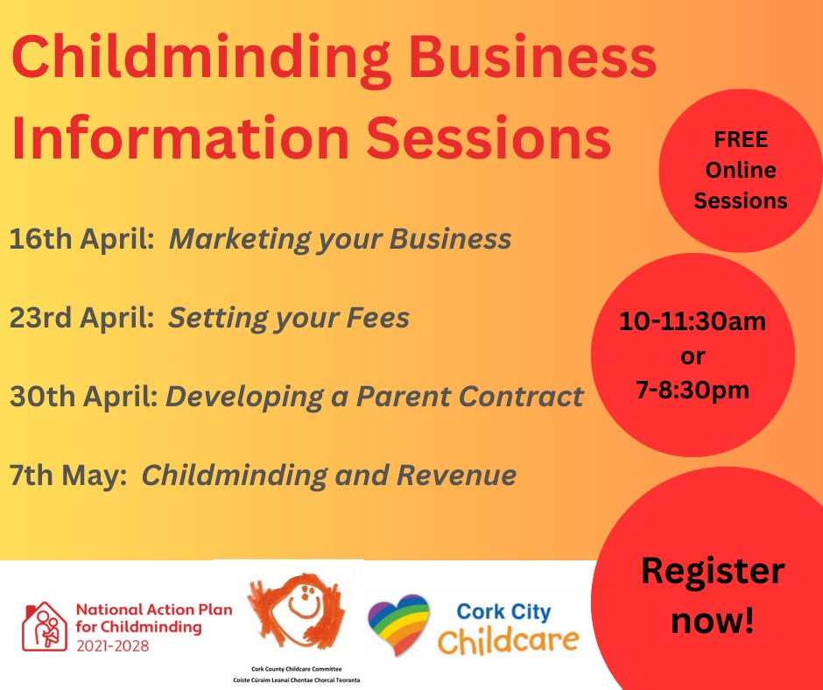
Cork City & County Childcare Committee are running the 4 Part Business Information Series for childminders throughout April and May. These sessions are for both existing and potential childminders and will be delivered in the morning from 10am -11.30am and in the evening from 7pm to 8.30pm.
To book a space on any of these information sessions please click this link: https://forms.office.com/e/BijbUNFrCr

If you have any queries, please contact info@corkchildcare.ie / 022-23880.

Trauma Informed Training
Cork County and Cork City Childcare Committees in partnership with Tusla have organised Trauma Informed Training for Childcare Providers. Further information on the training provided is available on the following link: https://www.traumainformed.ie/training This training may fulfil goals as identified through the Core Funding Quality Action Plan. Places on the course need to be booked by completing the attached booking form and returned to training@corkchildcare.ie
Current Training Dates: Both dates must be completed to receive certification.
- Saturday 11th & 18th May from 9am to 1pm
- Thursday 23rd & 30th May from 2pm to 6pm
- Saturday 8th & 15th June from 9am to 1pm
- Saturday 28th Sept & 5th Oct from 9am to 1pm

Welcome to April Happy Talkers!
In the Happy Talk Calendar this month we are learning new words, through play and fun, we love to play with the rhymes we know, to build our vocabulary, our sentences, and our stories.
We practice Listening Carefully in this month’s Happy Talk Mindful Moment! Listening helps us learn, relax, and enjoy lots of things! (Please see the calendar for April 2024 attached)
Covid case advice
Please find below links to information from the HPSC in relation to Covid-19 and information from the HSE for ELC and SAC providers on preventing the spread of Covid-19 and children returning to ELC and SAC settings. We would be grateful if you shared this information with parents, guardians, and staff. Preventing the spread of covid 19 in school or childcare - HSE In addition, please find link to the Management of Infectious Disease in Childcare Facilities and Other Childcare Settings (2012) For general Covid-19 queries you can contact HSE on 1800 700 700 between 8am and 8pm Monday to Friday and 9am - 5pm Saturday and Sunday or visit the HSE website HSE Covid 19
Should you have any queries on any of the above, please do not hesitate to contact us on 022-23880 or info@corkchildcare.ie
Cork County Childcare Committee Facebook Page
We invite you to visit our website here and like and follow our Facebook page Cork County Childcare Committee Ltd for lots of updates and relevant content here or scan the QR code.

Kind Regards,
Cork County Childcare Committee

