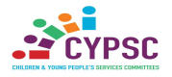

Cork CYPSC Supporting Parents Sub Group
Train The Trainer Workshop
This workshop for professionals who engage and support parents on a regular basis within their role, or who manage a team who do.
Cork CYPSC Supporting Parents Sub Group, developed 6 parent action leaflets for parents of children 0-24 years following consultation with parents across the county where parents told us what information would be helpful to them in their parenting role to support their child’s social and emotional wellbeing. (SEWB)
Following the parent consultation 6 parent action leaflets were developed in the four main languages in Cork. (English, French, Polish and Lithuanian)
Since 2019 Cork CYPSC Parent Sub Group has been delivering workshops for both parents and professionals across the city and county based on the parent action leaflets based on the key messages contained within the parent action leaflets.
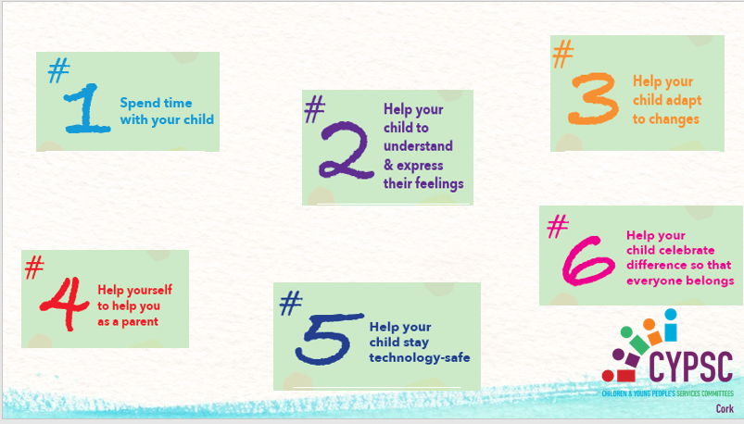

To facilitate a greater reach to Parents in Cork City and County we have now developed a Train the Trainer workshop to support professionals to deliver this workshop to parents they work with.

Why chose this training workshop?
This workshop is aimed at managers of or workers who regularly support and engage with parents of children and young people aged 0-24 years on a regular basis who also, give/are asked for parenting advice and guidance as part of their role. The aim is to provide organisations with the knowledge and resources from Cork CYPSC to facilitate parenting ‘action’ workshops in their area on “Ways to support your child’s social and emotional wellbeing.”
In completing this training workshop, attendees will:
- Gain access to CYPSC Parent Action Leaflets, in the four languages available and have guidance on how to use these in the course of their work.

- Increase and build on their knowledge of effective ways of supporting parents to support their children’s SEWB

- Gain an increased understanding of what matters to parents work from a strength-based and relationship centred approach.

- Gain insight into the barrier’s parents identify for engagement with services and what supports their engagement.

- Receive a toolkit to support facilitator to organise and run a workshop in their area.

- Become part of a CYPSC peer support network to promote learning, further development of the CYPSC Parent Action Resource supported by Cork CYPSC and to amplify the voice of parents via Cork CYPSC.

When and Where?
May 18th 2023 from 2 to 5pm in Childhood matters, Bessborough, Cork.

Commitment Required:
In signing up to this training workshop, the applicant commits to facilitating one parent workshop in their area within 6 months of completing the training.

Closing date for applications is 12th of May 2023. Places are limited early booking is advisable. https://forms.office.com/e/3GPXRWDdgL

